**Lesson3 APP13:**

**Set the Storage Class of an Object**

Selecting the bucket

* Select the bucket and open the list of items

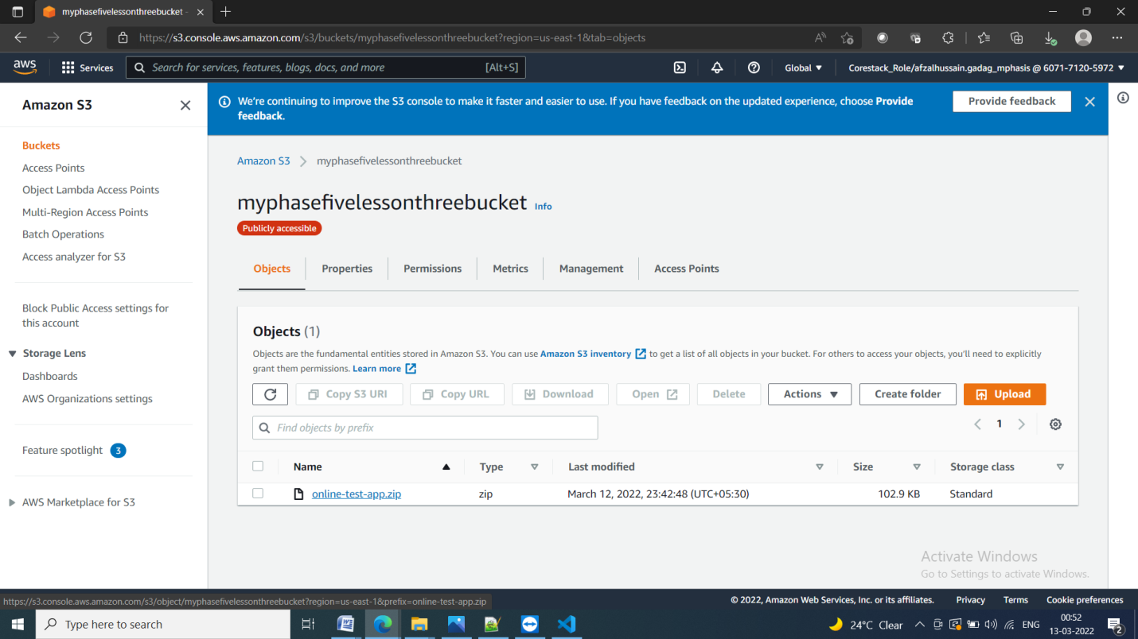

**Setting the storage class of an object**

* Click on *Upload* and select the file and scroll down to Properties

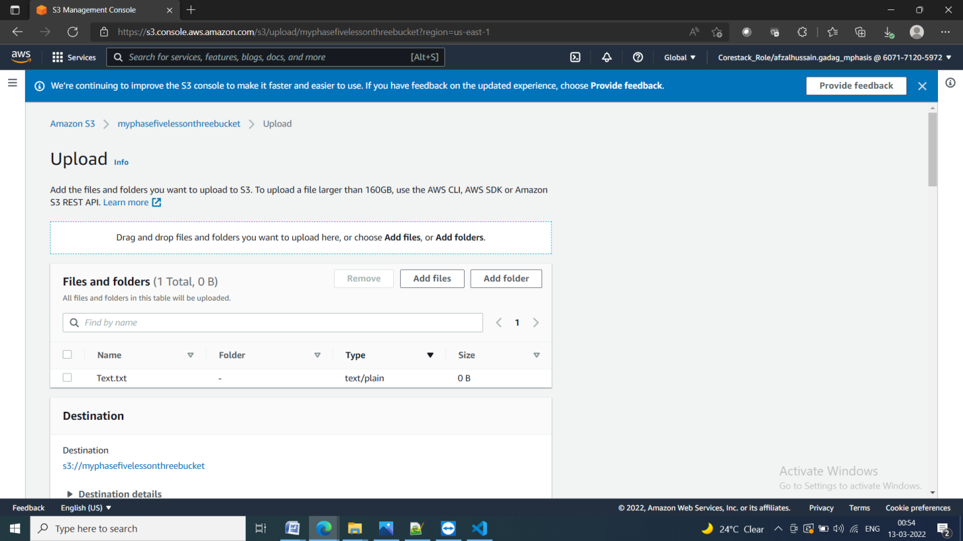

* Select the class and click uplode

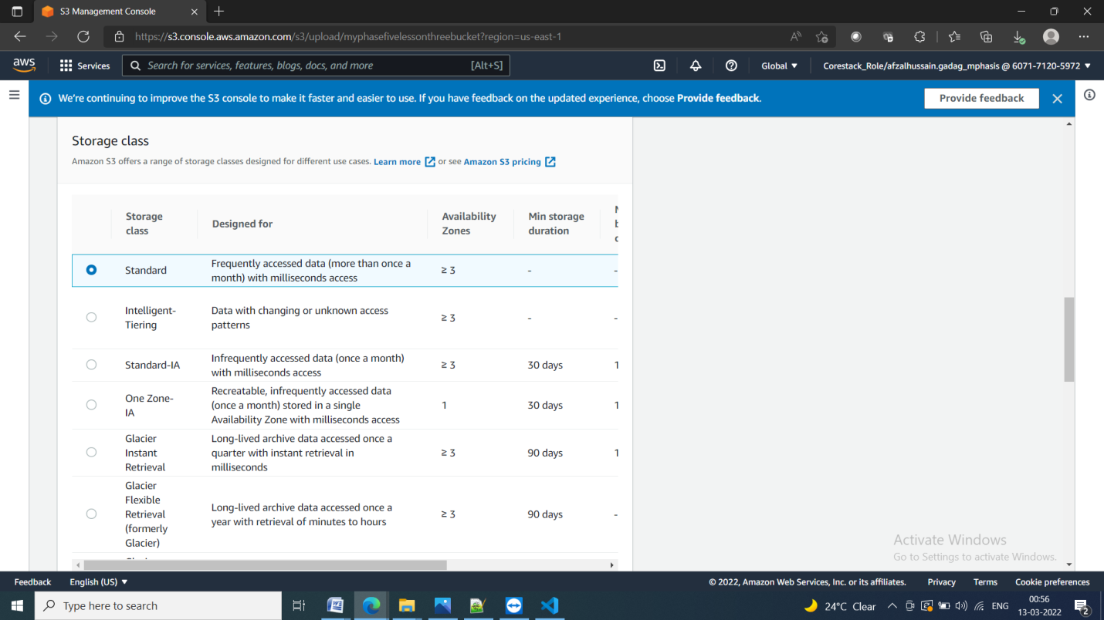

* The class will get assigned to the uploaded object

